CyberOps Associates v1.0 - Skills Assessment

Introduction
You have been hired as a junior security analyst. As part of your training, you were tasked to determine any malicious activity associated with the Pushdo trojan.
You will have access to the internet to learn more about the events. You can use websites, such as VirusTotal, to upload and verify threat existence.
The tasks below are designed to provide some guidance through the analysis process.
You will practice and be assessed on the following skills:
- Evaluate event alerts using Squil and Kibana.
- Use Google search as a tool to obtain intelligence on a potential exploit.
- Use VirusTotal to upload and verify threat existence.
Content for this assessment was obtained from http://www.malware-traffic-analysis.net/ and is used with permission. We are grateful for the use of this material.

Required Resources
- Host computer with at least 8GB of RAM and 45GB of free disk space
- Latest version of Oracle VirtualBox
- Security Onion virtual machine requires 4GB of RAM using 25GB disk space
- Internet access

Instructions

Gather the Basic Information
In this part, you will review the alerts listed in Security Onion VM and gather basic information for the interested time frame.

Verify the status of services
      - Log into Security Onion VM using with the username analyst and password cyberops.
      - Open a terminal window. Enter the sudo so-status command to verify that all the services are ready.
      - When the nsm service is ready, log into Sguil or Kibana with the username analyst and password cyberops.

Gather basic information.

Questions:
      - Identify time frame of the Pushdo trojan attack, including the date and approximate time.
Type your answers here.
      - List the alerts noted during this time frame associated with the trojan.
Type your answers here.
      - List the internal IP addresses and external IP addresses involved.
Type your answers here.

Learn about the Exploit
In this part, you will learn more about the exploit.

Infected host

Questions:
      - Based on the alerts, what is the IP and MAC addresses of the infected computer? Based on the MAC address, what is the vendor of the NIC chipset? (Hint: NetworkMiner or internet search)
Type your answers here.
      - Based on the alerts, when (date and time in UTC) and how was the PC infected? (Hint: Enter the command date in the terminal to determine the time zone for the displayed time)
Type your answers here.
How did the malware infect the PC? Use an internet search as necessary.
Type your answers here.

Examine the exploit.

Questions:
      - Based on the alerts associated with HTTP GET request, what files were downloaded? List the malicious domains observed and the files downloaded.
Type your answers here.
Use any available tools in Security Onion VM, determine and record the SHA256 hash for the downloaded files that probably infected the computer?
Type your answers here.
      - Navigate to www.virustotal.com input the SHA256 hash to determine if these were detected as malicious files. Record your findings, such as file type and size, other names, and target machine. You can also include any information that is provided by the community posted in VirusTotal.
Type your answers here.
      - Examine other alerts associated with the infected host during this timeframe and record your findings
Type your answers here.

Report Your Findings
Summarizes your findings based on the information you have gathered from the previous parts, summarize your findings.

Skills Exam Answers
Part 1
- Step 2
  - Screenshot in Sguil or Kibana showing the events the time frame of the Pushdo attack.
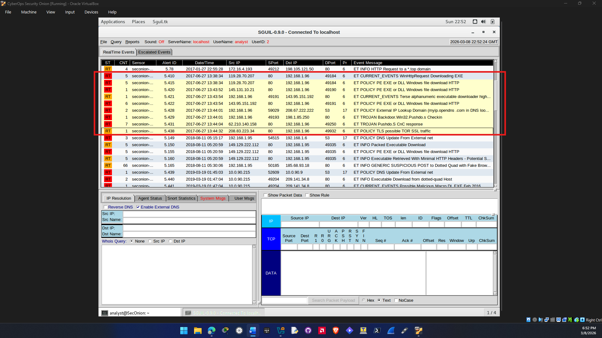
Question a.
Time frame of the Pushdo trojan attack: on 2017-06-27 occurred from 13:38:34 to 13:44:32

Question b.
Alerts noted during the time frame of the Pushdo trojan attack
ET CURRENT_EVENTS WinHttpRequest Downloading EXE
ET POLICY PE EXE or DLL Windows file download HTTP
ET POLICY PE EXE or DLL Windows file download HTTP
ET CURRENT_EVENTS Terse alphanumeric executable downloader high likelihood of being hostile
ET POLICY PE EXE or DLL Windows file download HTTP
ET POLICY External IP Lookup Domain (myip.opendns .com in DNS lookup)
ET TROJAN Backdoor.Win32.Pushdo.s Checkin
ET TROJAN Pushdo.S CnC response
ET POLICY TLS possible TOR SSL traffic

Question c.
Internal and external IP addresses involved in this trojan attack:
Internal IP address:
192.168.1.96
External IP addresses:
119.28.70.207
145.131.10.21
143.95.151.192
208.67.222.222
198.1.85.250
62.210.140.158
208.83.223.34

Part 2
- Step 1
Question a.
IP and MAC addresses of the infected computer:
IP - 192.168.1.96
MAC - 00:15:C5:DE:C7:3B
NIC Vendor is Dell Inc.

  - Screenshot showing the MAC address you found using NetworkMiner or internet search
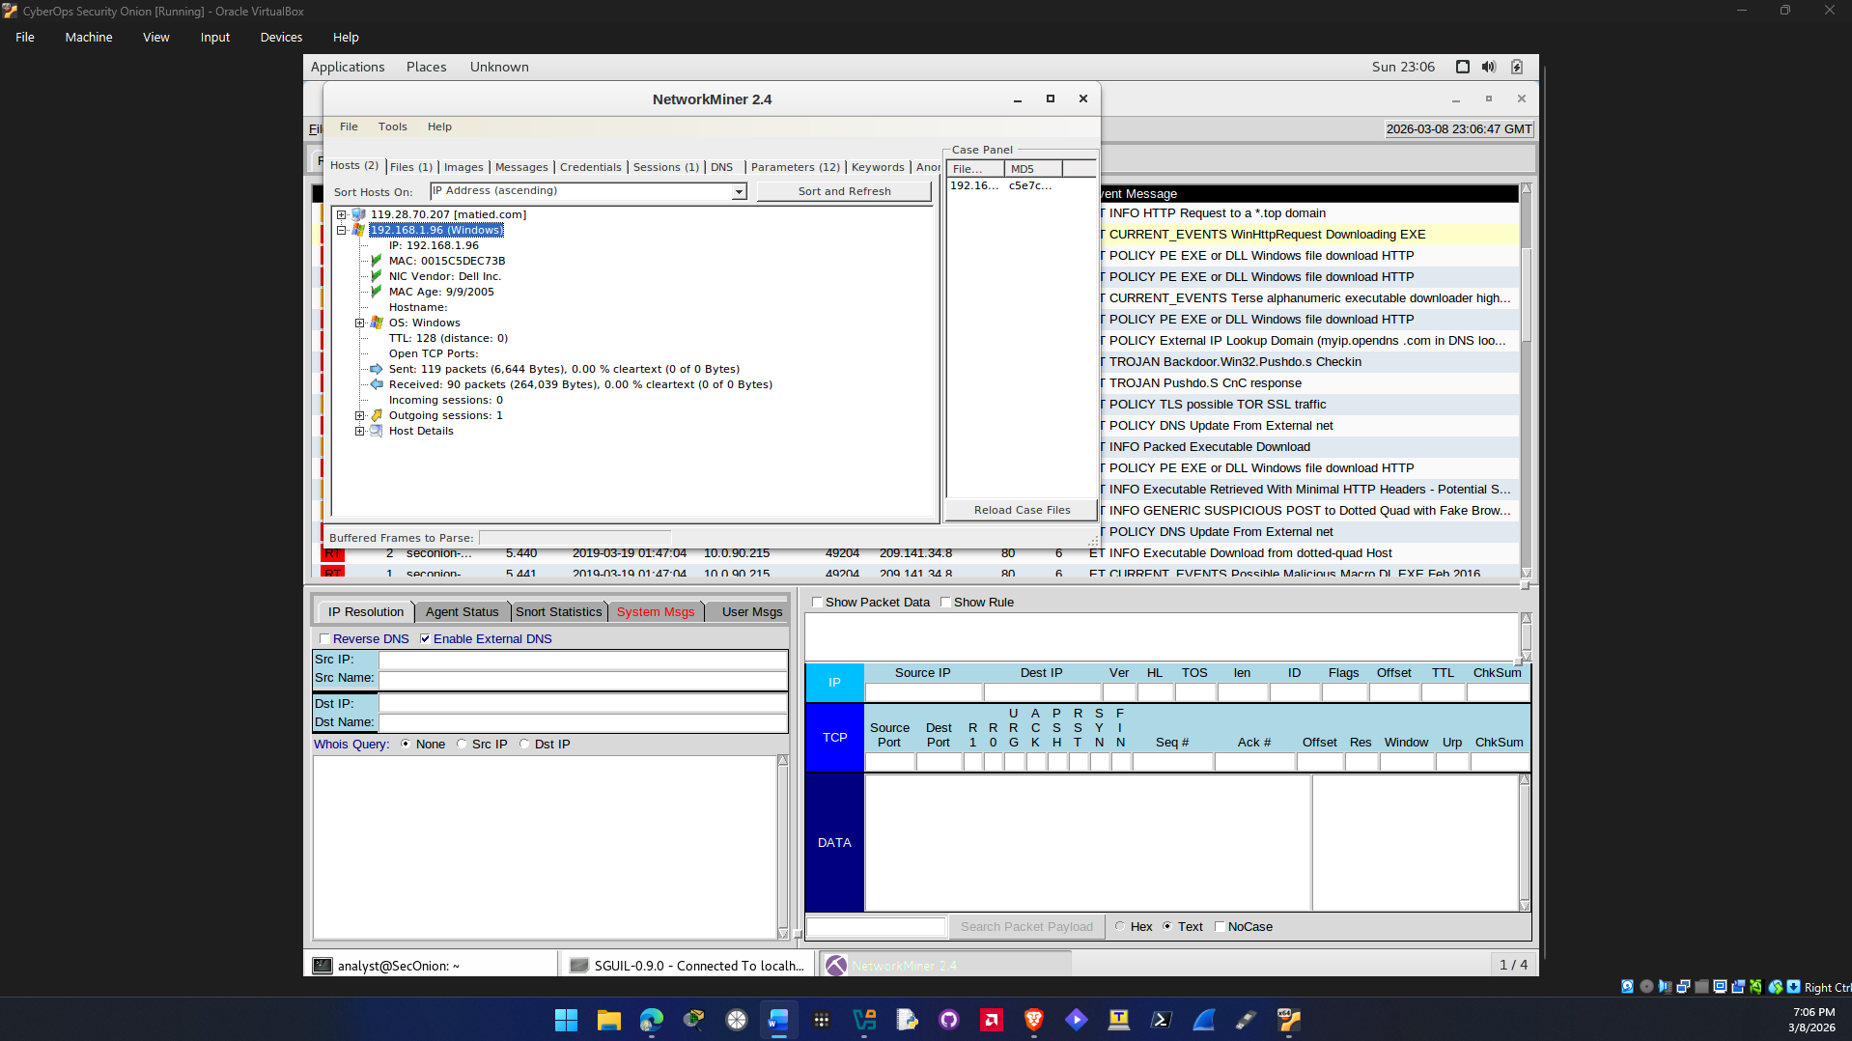

Question b.
Time/date and how the PC was infected:
Alert ID 5.410 2017-06-27 13:38:34 UTC
It looks like the host PC 192.168.1.96 connected ot the site matied.com which then downloaded a file gerv.gun which is malware and its associated with the Pushdo trojan

Question c.
The malware infected the PC when the user of host 192.168.1.96 accesed matied.com. The Pushdo trojan was then used to execute the malware gerv.gun.
Pushdo is a downloader trojan so its true purpose is to download and install additional malicious contents. Pushdo is more sophisticated than other downloader trojan families. This is due to the control server of Pushdo. So this is how gerv.gun was able to infect the PC other files were also downloaded because pushdo will try to deliver more malware over HTTP.

Source: https://malpedia.caad.fkie.fraunhofer.de/details/win.pushdo

Step 2: Examine the exploit
Questions a.
Files that were downloaded based upon the HTTP GET requests:
Gerv.gun: matied.com/gerv.gun
Trow.exe: lounge-haarstudio.nl/oud/trow.exe
wp.exe: vantagepointtechnologies.com/wp.exe

SHA256 hashes for the 3 downloaded files
Gerv.gun: 0931537889c35226d00ed26962ecacb140521394279eb2ade7e9d2afcf1a7272
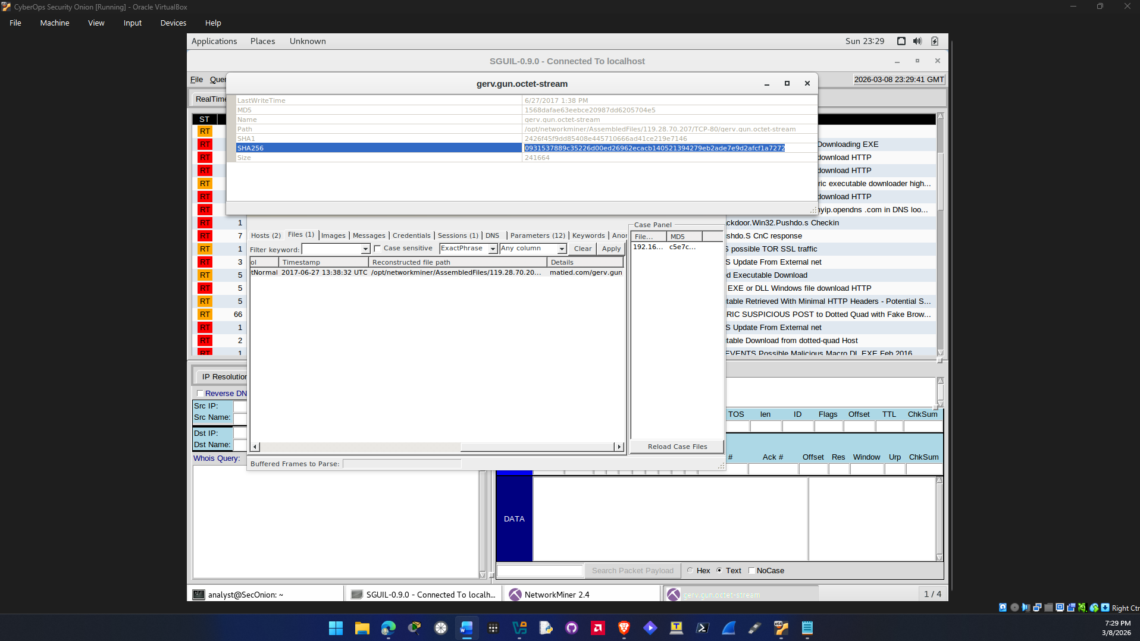

trow.exe:
94a0a09ee6a21526ac34d41eabf4ba603e9a30c26e6a1dc072ff45749dfb1fe1
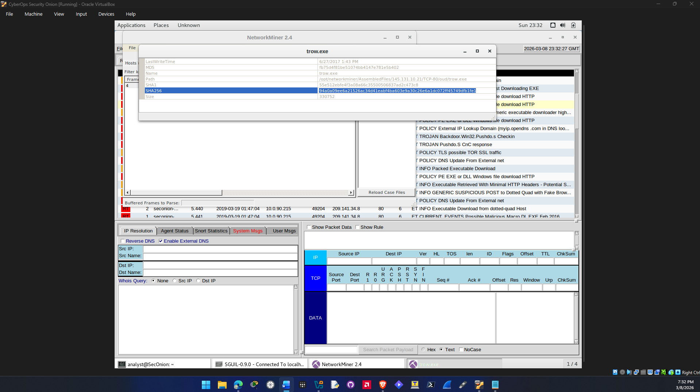

wp.exe:
79d503165d32176842fe386d96c04fb70f6ce1c8a485837957849297e625ea48
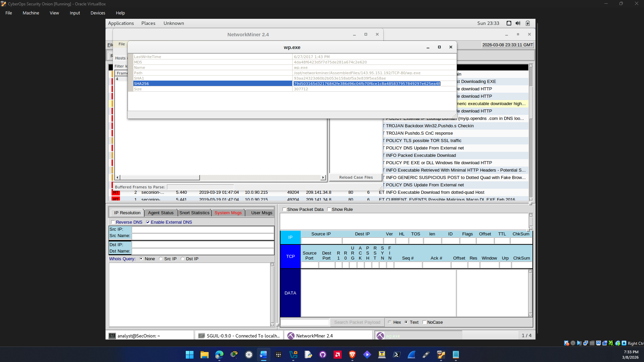
Question b.
VirusTotal search information for the 3 files:

gerv.gun: https://www.virustotal.com/gui/file/0931537889c35226d00ed26962ecacb140521394279eb2ade7e9d2afcf1a7272/details
58/70 security vendors flagged this file as malicious
Popular threat label for this file is trojan.shiotob/jaik
File Type: Win32 EXE
File Size: 236.00 KB
Other names:
gerv.gun[10].octet-stream
gerv.gun[7].octet-stream
gerv.gun[3].octet-stream
gerv.gun.octet-stream
gerv.gun.octet-stream.crdownload
gerv.gun
gerv.gun[4].octet-stream
HTTP-FG0jno3bJLiIzR4hrh.exe
gerv.gun[1].octet-stream
gerv.gun.exe
gerv.gun[24].octet-stream
gerv.gun[5].octet-stream
gerv.gun[2].octet-stream
gerv.gun[11].octet-stream
gerv.gun[12].octet-stream
gerv.gun[8].octet-stream
gerv.gun[6].octet-stream
(5.410) gerv.gun.octet-stream
gerv.zip
gerv (1).gun
gerv.gun.bin
img (1)
grun.exe
gerv.exe
gerv.gun[9].octet-stream
test
tmp523799.697
tmp246975.343
tmp213582.420
extract-1498570714.111294-HTTP-FG0jno3bJLiIzR4hrh.exe
0931537889c35226d00ed26962ecacb140521394279eb2ade7e9d2afcf1a7272.bin
vector.tui
Target Machine:
Intel 386 or later processors and compatible processors

trow.exe: https://www.virustotal.com/gui/file/94a0a09ee6a21526ac34d41eabf4ba603e9a30c26e6a1dc072ff45749dfb1fe1
65/72 security vendors flagged this file as malicious
Popular Threat Label is trojan.cutwail/wigon
File Type: Win32 EXE
File Size: 323.00 KB
Other Names:
Pedals
Pedals.exe
trow[1].exe
trow.exe
trow[4].exe
trow[3].exe
HTTP-FfmePA13Dx2LcgCLd.exe
trow.exe.quarantine
trow
taswexuahoft.exe
trow Suspect Executables
Suspect Executables
xecutables
94a0a09ee6a21526ac34d41eabf4ba603e9a30c26e6a1dc072ff45749dfb1fe1.exe
trow[9].exe
trow.PDF
trow[5].exe
suspect file1
trowexecutablepotential
suspect executables
steam 0.0
0.0 trow.exe
http0
steam5.5
steam 4.4
trow.html
suspect 2
Trow
throw2.exe
trow.http
trow1(1).exe
trow(3).exe
MalwareDownload
trow.dat
trow(1).exe
trow[2].exe
trow.bin
bad
test3
2017-06-28_18-18-14.exe
bma2beo4.exe
Target Machine:
Intel 386 or later processors and compatible processors

wp.exe: https://www.virustotal.com/gui/file/79d503165d32176842fe386d96c04fb70f6ce1c8a485837957849297e625ea48/detection
61/72 security vendors flagged this file as malicious
Popular Threat Label is Trojan.ursnif/nymaim
File Type: Win32 EXE
File Size: 300.50KB
Other Names:
wp.exe
wp[6].exe
wp[4].exe
wp.exe.quarantine
HTTP-FiS6Ty18r3jnk9xajj.exe
wp
wp Suspect Executables
Suspect Executables2
xecutables2
5422-wp.exe
malware
wp[1].exe
wp[2].exe
wp[9].exe
atltap32.exe
bdesbrkr.exe
wp[5].exe
binck.exe
wp(1).exe
suspect file 2
wpExecutablepotential1
suspect executables 2
Suspect Executables1
wp.exe1
wp.exe.bin
trow.exe
suspect 1
wp.http
wp.dat
test2
wp.bin
wp.exe.x-msdownload
4da48f6423d5f7d75de281a674c2e620.virobj
test_3
Target Machine:
Intel 386 or later processors and compatible processors

Question c.
Other alerts associated with the infected host:
Alert ID 5.428
ET POLICY External IP Lookup Domain (myip.opendns .com in DNS lookup)
The infection started when 192.168.1.96 performed a DNS lookup through the malicious ip of 208.67.222.222 which is what triggered an External IP address lookup by opendns. The malware was probably checking the public IP of the host 192.168.1.96 to check for vulnerabilities.
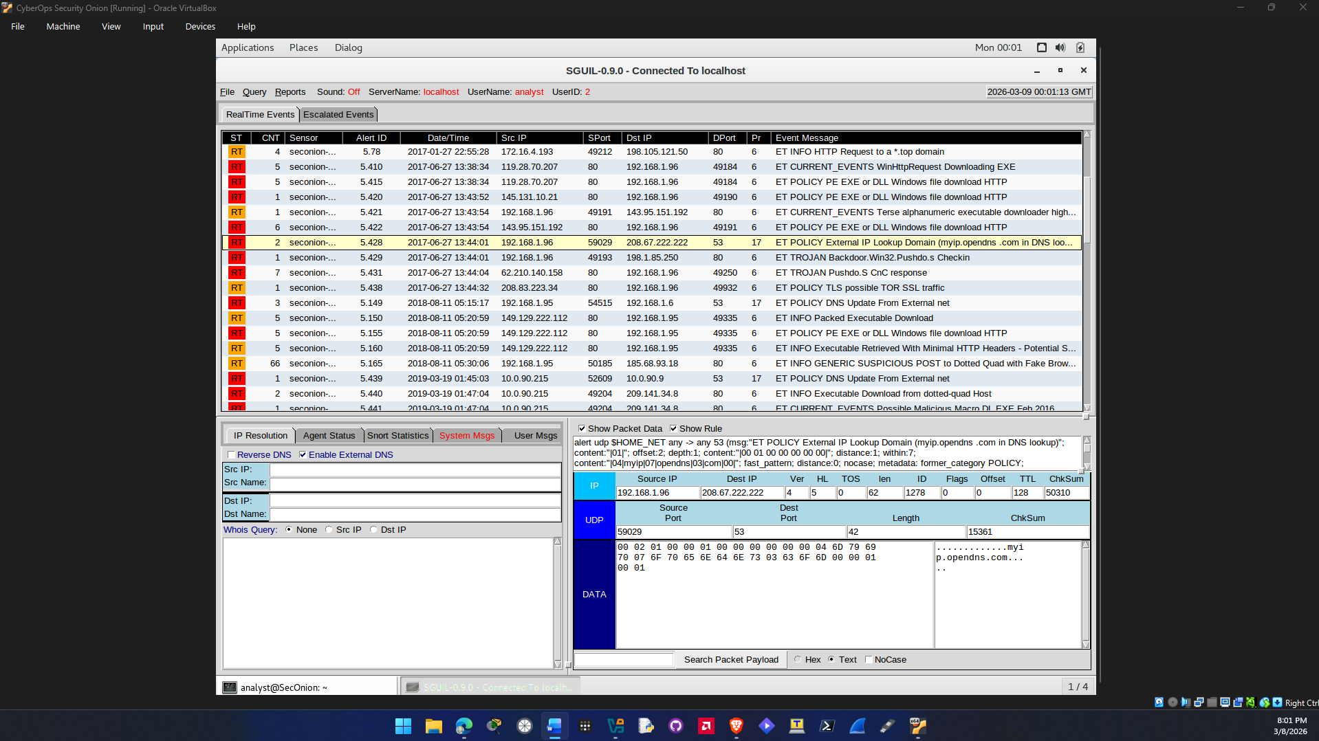
Alert 5.438
ET POLICY TLS possible TOR SSL traffic
The alert is showing a possible TOR connection with traffic associated with the host 192.168.1.96. This is probably unusual behavior that is not performed by the user of the host but probably by the trojan Pushdo deploying multiple files to the host.

Step 3: Report Your Finding
Refer to the SkillsExamReportTemplate

